Deploy an Application Using the Kubernetes Dashboard
Screen shots and source code
Contents
1. Create kubernetes environment 2
1.1 Create 3 ec2 instances in AWS 2
1.2 Run command on master node 2
1.3 Run command on worker nodes 4
1.4 How cluster join command appears in output? 5
1.5 Run cluster join command on worker nodes 6
2 Get started with pods, services, and deployments 7
2.1 Deploy basic httpd service and access it 7
2.2 Run Basic Deployment and check website is working 8
2.3 Test from browse 8
3 Create a token and work on a dashboard 9
3.1 Deploy Kubernetes Dashboard 9
3.2 Create Service Account 9
3.3 Create ClusterRoleBinding (Admin Access) 9
3.4 Generate Token 10
3.5 Access Dashboard 10
3.6 Login 11
4 create persistent volume 12
5 create secret for mysql 13
6 create persistent volume claim for mysql 14
7 deploy mysql 15
8 create configmap for wordpress 16
9 create persistent volume claim for wordpress 17
10 deploy wordpress 18
11 dashboard view check again 22

Create kubernetes environment

Create 3 ec2 instances in AWS
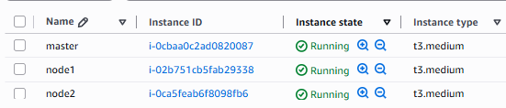

Run command on master node
Below code will show cluster join command at the end
## CREATE 3 T3.medium machine with all traffic enabled

#In master machine:

#Step 1 : Update and Upgrade Ubuntu
sudo apt-get update
sudo apt-get upgrade

sudo swapoff -a
sudo sed -i '/ swap / s/^\(.*\)$/#\1/g' /etc/fstab

##

sudo tee /etc/modules-load.d/containerd.conf <<EOF
overlay
br_netfilter
EOF

##

sudo modprobe overlay
sudo modprobe br_netfilter

##
sudo tee /etc/sysctl.d/kubernetes.conf <<EOF
net.bridge.bridge-nf-call-ip6tables = 1
net.bridge.bridge-nf-call-iptables = 1
net.ipv4.ip_forward = 1
EOF

##

sudo sysctl --system

##

sudo apt install -y curl gnupg2 software-properties-common apt-transport-https ca-certificates
sudo curl -fsSL https://download.docker.com/linux/ubuntu/gpg | sudo gpg --dearmour -o /etc/apt/trusted.gpg.d/docker.gpg
sudo add-apt-repository "deb [arch=amd64] https://download.docker.com/linux/ubuntu $(lsb_release -cs) stable"

sudo apt update
sudo apt install -y containerd.io

containerd config default | sudo tee /etc/containerd/config.toml >/dev/null 2>&1
sudo sed -i 's/SystemdCgroup \= false/SystemdCgroup \= true/g' /etc/containerd/config.toml

sudo systemctl restart containerd
sudo systemctl enable containerd

##

sudo apt-get update
# apt-transport-https may be a dummy package; if so, you can skip that package
sudo apt-get install -y apt-transport-https ca-certificates curl gpg

curl -fsSL https://pkgs.k8s.io/core:/stable:/v1.29/deb/Release.key | sudo gpg --dearmor -o /etc/apt/keyrings/kubernetes-apt-keyring.gpg

# This overwrites any existing configuration in /etc/apt/sources.list.d/kubernetes.list
echo 'deb [signed-by=/etc/apt/keyrings/kubernetes-apt-keyring.gpg] https://pkgs.k8s.io/core:/stable:/v1.29/deb/ /' | sudo tee /etc/apt/sources.list.d/kubernetes.list

##

sudo apt-get update
sudo apt-get install -y kubelet kubeadm kubectl
sudo apt-mark hold kubelet kubeadm kubectl

##

modprobe br_netfilter
echo 1 > /proc/sys/net/bridge/bridge-nf-call-iptables
echo 1 > /proc/sys/net/ipv4/ip_forward

##

sudo kubeadm init

mkdir -p $HOME/.kube
sudo cp -i /etc/kubernetes/admin.conf $HOME/.kube/config
sudo chown $(id -u):$(id -g) $HOME/.kube/config

kubectl apply -f https://raw.githubusercontent.com/projectcalico/calico/v3.25.0/manifests/calico.yaml

##################
##################
###################

Run command on worker nodes
Code
## NOW RUN THE BELOW COMMANDS IN THE NODES ######

sudo apt-get update
sudo apt-get upgrade

sudo swapoff -a
sudo sed -i '/ swap / s/^\(.*\)$/#\1/g' /etc/fstab

##

sudo tee /etc/modules-load.d/containerd.conf <<EOF
overlay
br_netfilter
EOF

##

sudo modprobe overlay
sudo modprobe br_netfilter

##
sudo tee /etc/sysctl.d/kubernetes.conf <<EOF
net.bridge.bridge-nf-call-ip6tables = 1
net.bridge.bridge-nf-call-iptables = 1
net.ipv4.ip_forward = 1
EOF

##

sudo sysctl --system

##

sudo apt install -y curl gnupg2 software-properties-common apt-transport-https ca-certificates
sudo curl -fsSL https://download.docker.com/linux/ubuntu/gpg | sudo gpg --dearmour -o /etc/apt/trusted.gpg.d/docker.gpg
sudo add-apt-repository "deb [arch=amd64] https://download.docker.com/linux/ubuntu $(lsb_release -cs) stable"

sudo apt update
sudo apt install -y containerd.io

containerd config default | sudo tee /etc/containerd/config.toml >/dev/null 2>&1
sudo sed -i 's/SystemdCgroup \= false/SystemdCgroup \= true/g' /etc/containerd/config.toml

sudo systemctl restart containerd
sudo systemctl enable containerd

##

sudo apt-get update
# apt-transport-https may be a dummy package; if so, you can skip that package
sudo apt-get install -y apt-transport-https ca-certificates curl gpg

curl -fsSL https://pkgs.k8s.io/core:/stable:/v1.29/deb/Release.key | sudo gpg --dearmor -o /etc/apt/keyrings/kubernetes-apt-keyring.gpg

# This overwrites any existing configuration in /etc/apt/sources.list.d/kubernetes.list
echo 'deb [signed-by=/etc/apt/keyrings/kubernetes-apt-keyring.gpg] https://pkgs.k8s.io/core:/stable:/v1.29/deb/ /' | sudo tee /etc/apt/sources.list.d/kubernetes.list

##

sudo apt-get update
sudo apt-get install -y kubelet kubeadm kubectl
sudo apt-mark hold kubelet kubeadm kubectl

### NOW COPY THE JOIN COMMAND WHICH APPEARED IN MASTER MACHINE and paste it THE NODE

How cluster join command appears in output?
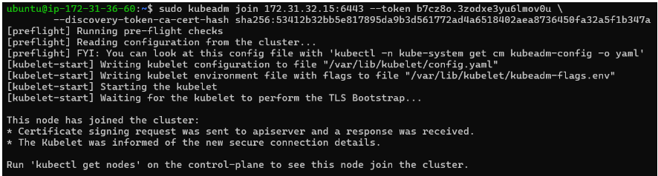

Run cluster join command on worker nodes
NOW COPY THE JOIN COMMAND WHICH APPEARED IN MASTER MACHINE and paste it THE NODE
sudo kubeadm join 172.31.32.15:6443 --token b7cz8o.3zodxe3yu6lmov0u --discovery-token-ca-cert-hash sha256:53412b32bb5e817895da9b3d561772ad4a6518402aea8736450fa32a5f1b347a

Get started with pods, services, and deployments

Deploy basic httpd service and access it
K8s manifest to deploy basic test deployment
---
kind: Deployment
apiVersion: apps/v1
metadata:
name: mydep
spec:
replicas: 5
selector:
matchLabels:
app: httpd
template:
metadata:
labels:
app: httpd
spec:
containers:
- name: c01
image: httpd
ports:
- containerPort: 80
---
kind: Service
apiVersion: v1
metadata:
name: myservice
spec:
selector:
app: httpd
type: NodePort
ports:
- protocol: TCP
port: 8080
targetPort: 80

Run Basic Deployment and check website is working
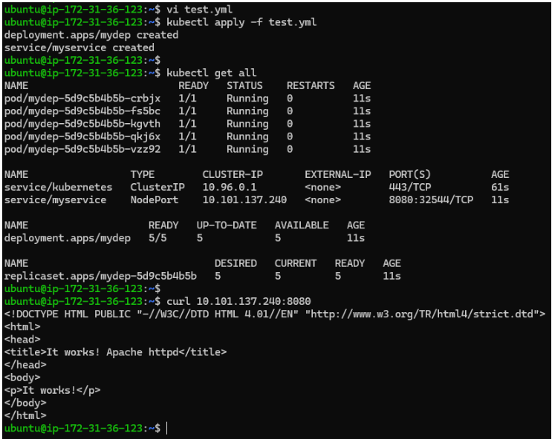

Test from browse
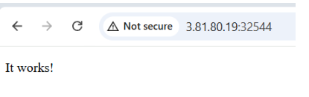

Create a token and work on a dashboard

Deploy Kubernetes Dashboard
Run below command
kubectl apply -f https://raw.githubusercontent.com/kubernetes/dashboard/v2.7.0/aio/deploy/recommended.yaml
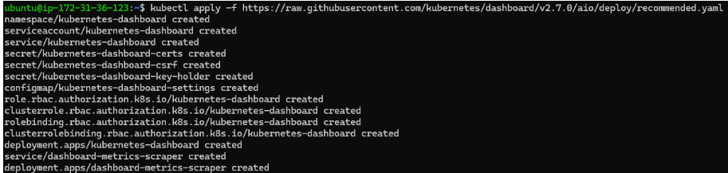

Create Service Account
Create manifest file
service-account.yaml
# service-account.yaml
apiVersion: v1
kind: ServiceAccount
metadata:
name: admin-user
namespace: kubernetes-dashboard

Apply
kubectl apply -f service-account.yaml

Output:
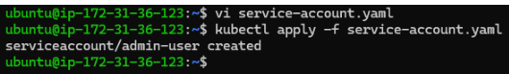

Create ClusterRoleBinding (Admin Access)
Create manifest file
cluster-role-binding.yaml
# cluster-role-binding.yaml
apiVersion: rbac.authorization.k8s.io/v1
kind: ClusterRoleBinding
metadata:
name: admin-user
roleRef:
apiGroup: rbac.authorization.k8s.io
kind: ClusterRole
name: cluster-admin
subjects:
- kind: ServiceAccount
name: admin-user
namespace: kubernetes-dashboard

Apply
kubectl apply -f cluster-role-binding.yaml

Output
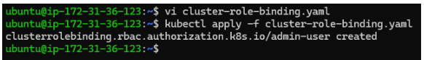

Generate Token
Run command to generate token (copy bearer token)
kubectl -n kubernetes-dashboard create token admin-user

Output
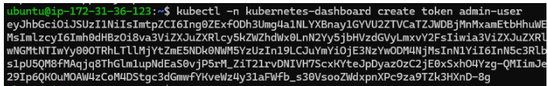

Access Dashboard
Terminal 1 – connect master node (SSH Tunnel — on laptop)
👉 This creates the tunnel. Keep this OPEN (don’t run anything else here)
ssh -i key.pem -L 8443:127.0.0.1:8443 ubuntu@50.17.51.12

Terminal 2 – connect master node again (Run proxy — inside EC2)
ssh -i key.pem ubuntu@50.17.51.12

then run port mapping command
kubectl port-forward -n kubernetes-dashboard svc/kubernetes-dashboard 8443:443

now browse this URL
https://localhost:8443/

Login
steps
- Choose Token.
- Paste the token you generated
- Click Sign In
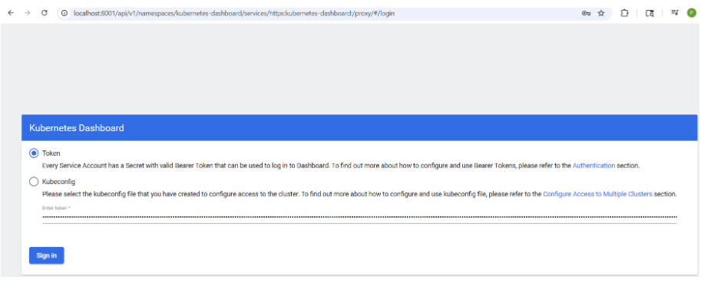
view dashboard
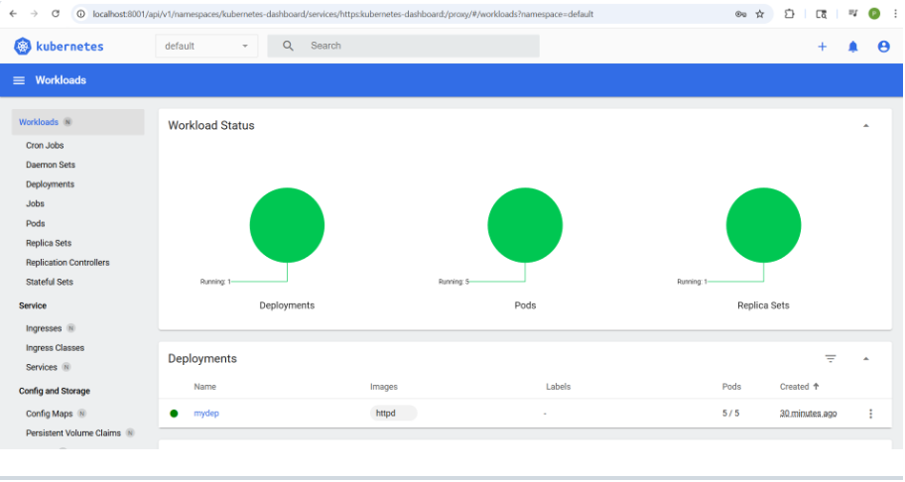

create persistent volume
Create persistent volume manifest
01-pv.yml
# create PersistentVolume for mysql
---
apiVersion: v1
kind: PersistentVolume
metadata:
name: manual-pv-mysql
spec:
capacity:
storage: 30Gi
accessModes:
- ReadWriteOnce
hostPath:
path: /mnt/data/mysql
type: DirectoryOrCreate
persistentVolumeReclaimPolicy: Retain
storageClassName: manual

---
# create PersistentVolume for wordpress

---
apiVersion: v1
kind: PersistentVolume
metadata:
name: manual-pv-wordpress
spec:
capacity:
storage: 40Gi
accessModes:
- ReadWriteOnce
hostPath:
path: /mnt/data/wordpress
type: DirectoryOrCreate
persistentVolumeReclaimPolicy: Retain
storageClassName: manual

Apply and output
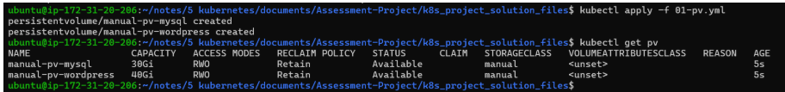

create secret for mysql
create manifest
02-mysql-secret.yml
# create secret for mysql. create secure script using command: echo -n 'mysecretpassword' | base64
# create secret option can be skipped if created manually: kubectl create secret generic mysql-pass --from-literal=password=mysecretpassword

---
kind: Secret
apiVersion: v1
metadata:
name: mysql-pass
type: Opaque
data:
password: bXlzZWNyZXRwYXNzd29yZA==

Apply and Output
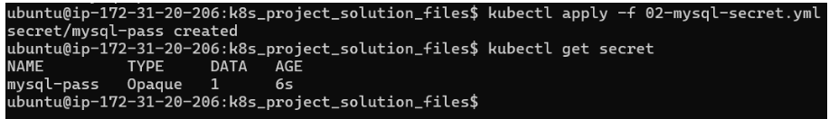

create persistent volume claim for mysql
create manifest
03-mysql-pvc.yml
---
kind: PersistentVolumeClaim
apiVersion: v1
metadata:
name: mysql-pv-claim
spec:
accessModes:
- ReadWriteOnce
storageClassName: manual
volumeName: manual-pv-mysql
resources:
requests:
storage: 20Gi

Apply and output
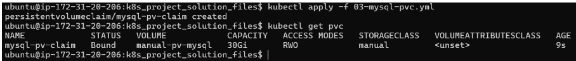

deploy mysql
create manifest
04-deploy-mysql.yml
---
kind: Deployment
apiVersion: apps/v1
metadata:
name: mysql
spec:
replicas: 1
selector:
matchLabels:
app: mysql # this should match
template:
metadata:
labels:
app: mysql # this should match
spec:
containers:
- name: mysql
image: mysql:5.7
env:
- name: MYSQL_USER
value: wordpress
- name: MYSQL_PASSWORD
valueFrom:
secretKeyRef:
name: mysql-pass
key: password
- name: MYSQL_DATABASE
value: wordpress
ports:
- containerPort: 3306
volumeMounts:
- name: mysql-persistent-storage
mountPath: /var/lib/mysql
volumes:
- name: mysql-persistent-storage
persistentVolumeClaim:
claimName: mysql-pv-claim

---
kind: Service
apiVersion: v1
metadata:
name: mysql
spec:
selector:
app: mysql
ports:
- port: 3306

apply and output
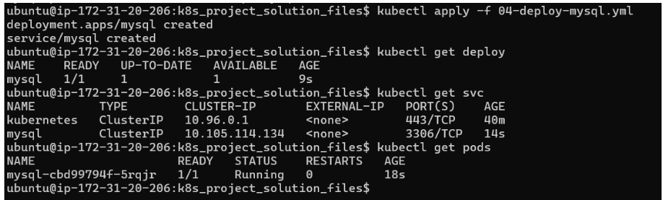

create configmap for wordpress
create manifest
05-configmap-wp.yml
# deploy wordpress
---
# create a ConfigMap YAML file
kind: ConfigMap
apiVersion: v1
metadata:
name: wordpress-config
data:
WORDPRESS_CONFIG_EXTRA: |
define('WP_DEBUG', true);
define('WP_POST_REVISIONS', 5);
WORDPRESS_SITE_TITLE: "My Demo Wordpress Site"
WORDPRESS_ADMIN_EMAIL: "pradeep.viswa@gmail.com"
WORDPRESS_DATABASE_HOST: "mysql"
WORDPRESS_DATABASE_NAME: "wordpress"
WORDPRESS_DATABASE_USER: "wordpress"

apply and output
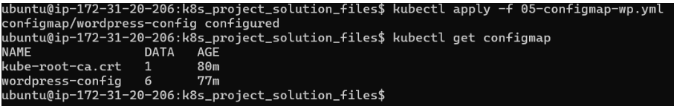

create persistent volume claim for wordpress
create manifest
06-wp-pvc.yml
---
kind: PersistentVolumeClaim
apiVersion: v1
metadata:
name: wp-pv-claim
spec:
accessModes:
- ReadWriteOnce
storageClassName: manual
volumeName: manual-pv-wordpress
resources:
requests:
storage: 20Gi

apply and output
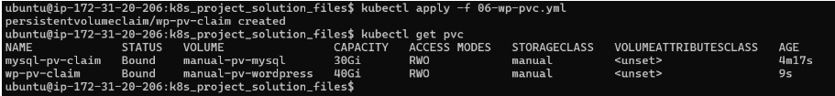

deploy wordpress
create manifest
07-deploy-wp.yml
---
kind: Deployment
apiVersion: apps/v1
metadata:
name: wordpress
spec:
replicas: 1
selector:
matchLabels:
app: wordpress
template:
metadata:
labels:
app: wordpress
spec:
containers:
- name: wordpress
image: bitnami/wordpress:latest # wordpress:latest alsowe can use
env:
- name: WORDPRESS_CONFIG_EXTRA
valueFrom:
configMapKeyRef:
name: wordpress-config
key: WORDPRESS_CONFIG_EXTRA
- name: WORDPRESS_SITE_TITLE
valueFrom:
configMapKeyRef:
name: wordpress-config
key: WORDPRESS_SITE_TITLE
- name: WORDPRESS_ADMIN_EMAIL
valueFrom:
configMapKeyRef:
name: wordpress-config
key: WORDPRESS_ADMIN_EMAIL

- name: WORDPRESS_DATABASE_HOST
valueFrom:
configMapKeyRef:
name: wordpress-config
key: WORDPRESS_DATABASE_HOST
- name: WORDPRESS_DATABASE_NAME
valueFrom:
configMapKeyRef:
name: wordpress-config
key: WORDPRESS_DATABASE_NAME
- name: WORDPRESS_DATABASE_USER
valueFrom:
configMapKeyRef:
name: wordpress-config
key: WORDPRESS_DATABASE_USER

- name: WORDPRESS_DATABASE_PASSWORD
valueFrom:
secretKeyRef:
name: mysql-pass
key: password
ports:
- containerPort: 8080
volumeMounts:
- name: wp-persistent-storage
mountPath: /var/www/html
volumes:
- name: wp-persistent-storage
persistentVolumeClaim:
claimName: wp-pv-claim

---
# Service to expose wordpress
kind: Service
apiVersion: v1
metadata:
name: wordpress
spec:
type: NodePort
selector:
app: wordpress
ports:
- port: 8080
targetPort: 8080
nodePort: 30007

apply and output
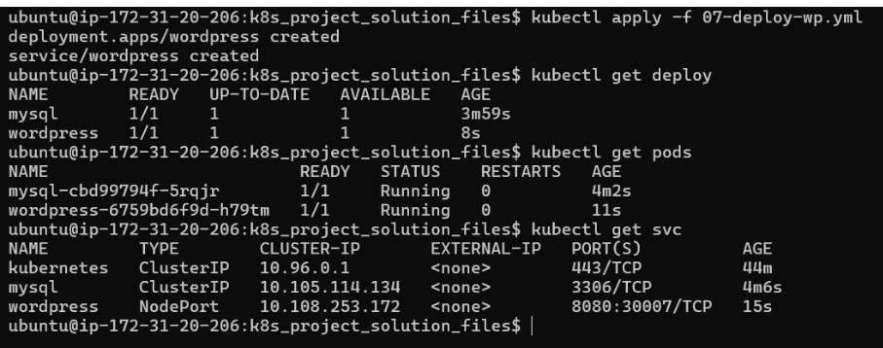

Success log of wordpress container
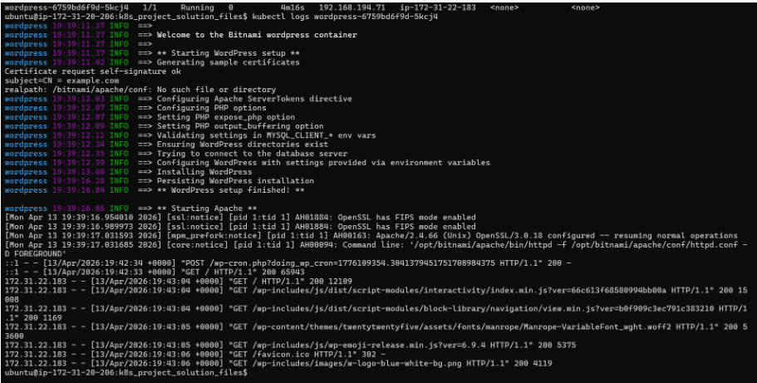

login to wordpress website
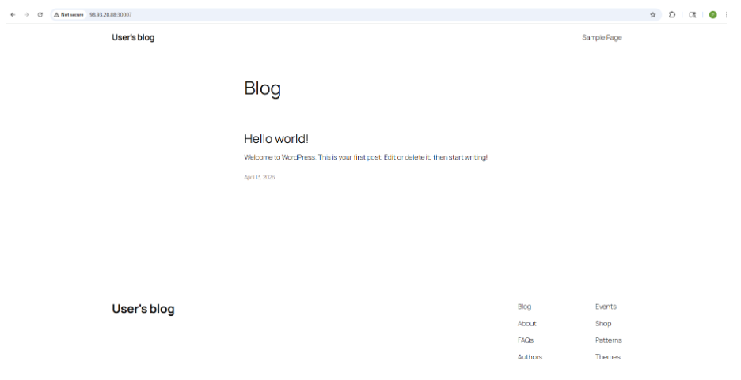

Posted some command – making sure DB connection is working
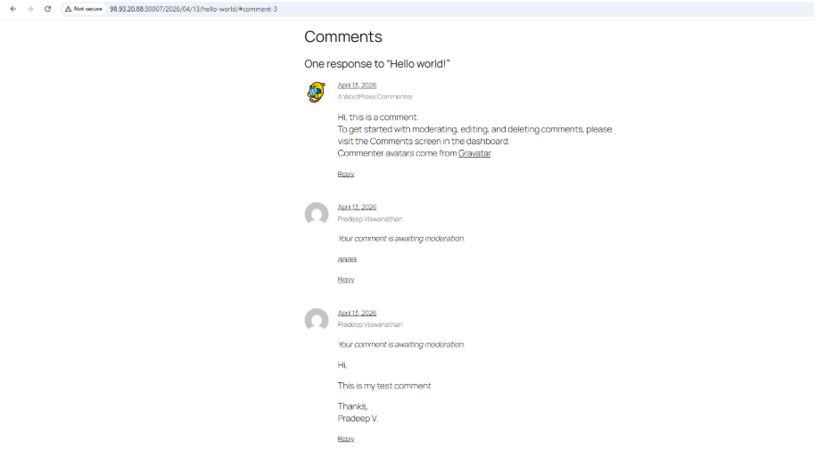

dashboard view check again
Dashboard URL
https://localhost:8443/#/workloads?namespace=default

Dashboard Stats
